Greater Cleveland Partnership sets plan for new socially focused loan fund
STAN BULLARD
- TWEET
- SHARE
- SHARE
- EMAIL
PRINT
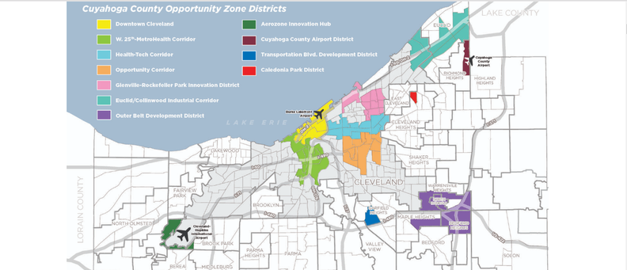
CONTRIBUTED MAP
Federally-designated Opportunity Zones will be the primary, but not the only, beneficiaries of a new loan fund that Greater Cleveland Partnership has announced that Cleveland Development Advisors will create. (Source: Opportunity CLE.)
Greater Cleveland Partnership, the region's chamber of commerce, plans to launch through its Cleveland Development Advisors affiliate a $50 million fund geared to gaining more opportunity zone investments in the region.
GCP announced plans to form the new fund, which it expects to leverage as much as $700 million in investments in targeted distressed areas, at its annual meeting Monday, June 10, at the Cleveland Museum of Art.
Joe Roman, president and CEO of GCP, said in a release on the new fund that, "This is an opportunity for all of us to step up and work together as a community by helping finance well-conceived projects that can create jobs and improve residents lives.''
The program is designed to target investments in the 64 Opportunity Zones in Cuyahoga County, but may also incorporate other distressed neighborhoods. Opportunity Zones were created by the most recent revision of the federal tax code to benefit economically distressed areas. Such qualifying investments offer taxpayers and companies with capital gains the chance to shelter them from federal taxes by investing in businesses or real estate projects inside the zones.
Yvette Ittu, CDA president, said in a phone interview Monday, June 10, that the fund will provide low-interest loans that meet terms for investments in Opportunity Zones. However, it is on the debt side rather than equity investments in projects and companies in the zones that have generated most of the appetite for Opportunity Zone projects.
"We see this as another tool in the tool belt to assist projects," Ittu said, "and be more intentional than in the past." She said she is not aware of another civic group launching such a fund geared to the new Opportunity Zone program.
That means projects or businesses will be selected for funding based on the ability to provide social benefits through business, jobs, education and other criteria. Ittu said the fund, called the Opportunity CLE Development Fund, will make loans of varying amounts based on the type of project and need, and will offer below-market interest rates. That means loans may be below the already low 4% range that is currently available in the commercial market.
CDA and GCP worked with the Washington, D.C.-based Urban Institute to develop criteria for the program that will ensure it meets the social benefits it hopes to promote and create measurable community impact.
Those criteria include:
• Delivering best-in-class mixed-income and transit-oriented developments
• Driving business and job creation opportunities to vacant sites
• Increasing opportunities for minority and female business enterprises
• Supporting developments that activate neighborhoods
• Increasing broadband access to unconnected areas of the community
Ittu said CDA's strategy is to support projects in areas around major corridors where significant public infrastructure and institutional investment has or is expected to occur. Those areas would include the HealthTech Corridor, the West 25th Street/MetroHealth Corridor and the Opportunity Corridor.
"Strengthening the feasibility of projects that will make the greatest difference and provide equitable outcomes in low-income neighborhoods and communities is a cornerstone of the fund and the future of Greater Cleveland," Ittu said.
She said she expects that the Opportunity CLE Development Fund will likely join with other capital sources to finance benefiting projects.
Donors to the fund are expected to be financial institutions, corporations and other philanthropic partners.
Paul Clark, chairman of CDA and retired PNC Bank regional president, said the new fund is a natural effort for CDA because of its 30-year track record of investing in catalytic real estate projects.
"They have helped finance more than 100 projects that have renewed and re-invigorated Northeast Ohio," Clark said in a news release. "I believe this newest fund will pay significant civic dividends by increasing private investment in strategic, targeted development.''
Over the years, CDA has directly invested more than $448 million and leveraged $3.8 billion in new investments in strategic real estate development projects. Those projects have created an estimated 6,750 new housing units and 7 million square feet of commercial space.
Ittu said CDA will also continue to operate its other development funds.

