EMPLOYEE TAX DOCUMENTS W2’S

To View/Print Your W2

Log into Workday
On your Home Page the link can be found under TIMELY SUGGESTIONS
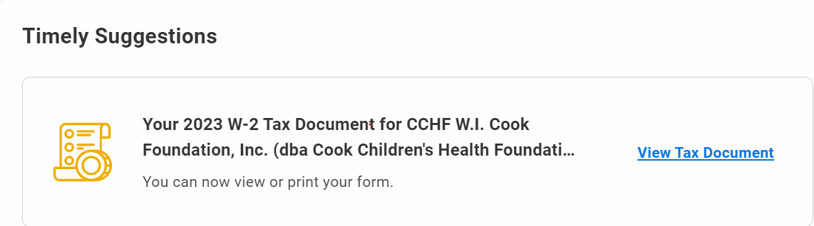

Click on View Tax Document Link
Page will display Tax Year with a button to View/Print
Click on View/Print
You may receive a “Notify Me Later” message
You can click this option, however, If you wait 10 seconds or so your W2 will automatically populate the window

OR

Click on your photo in the top right hand corner
Click on View Profile
Click Menu
Benefits and Pay
My Tax Documents
You should see the tax year to view/print
Click View/Print
Gives a preview of W2

** Employees who may have received a Pre-Hire sign on bonus will find a second W-2 posted under the “Pre-hire Employee ID Number”.

